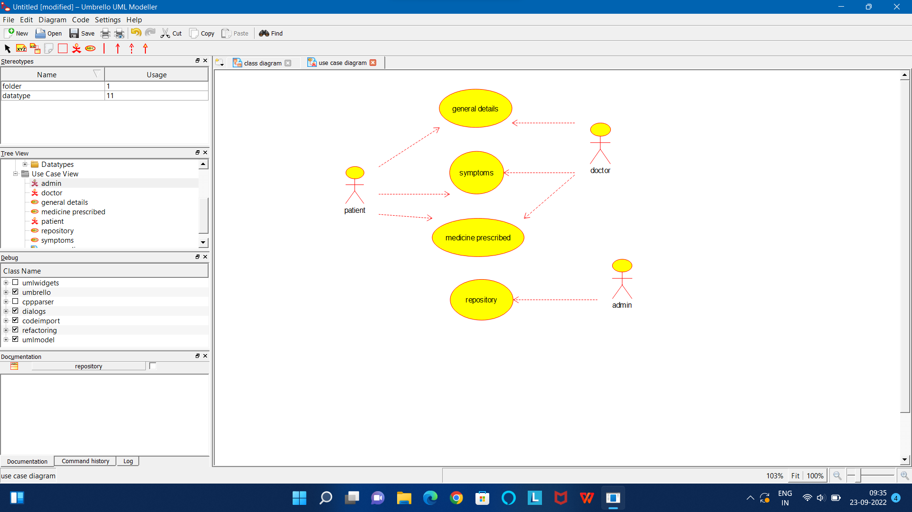

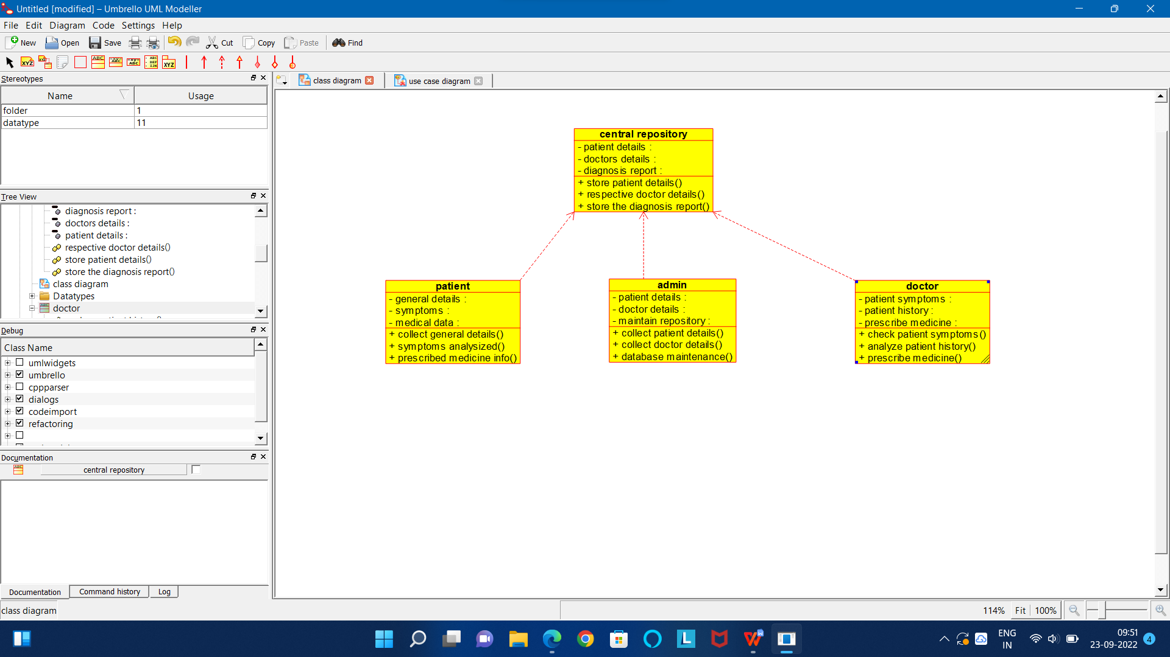

CODE FOR ADMIN:

/**

* Class admin

*/

public class admin {

//

// Fields

//

private void patient_details;

private void doctor_details;

private void maintain_repository;

//

// Constructors

//

public admin () { };

//

// Methods

//

//

// Accessor methods

//

/**

* Set the value of patient_details

* @param newVar the new value of patient_details

*/

private void setPatient_details (void newVar) {

patient_details = newVar;

}

/**

* Get the value of patient_details

* @return the value of patient_details

*/

private void getPatient_details () {

return patient_details;

}

/**

* Set the value of doctor_details

* @param newVar the new value of doctor_details

*/

private void setDoctor_details (void newVar) {

doctor_details = newVar;

}

/**

* Get the value of doctor_details

* @return the value of doctor_details

*/

private void getDoctor_details () {

return doctor_details;

}

/**

* Set the value of maintain_repository

* @param newVar the new value of maintain_repository

*/

private void setMaintain_repository (void newVar) {

maintain_repository = newVar;

}

/**

* Get the value of maintain_repository

* @return the value of maintain_repository

*/

private void getMaintain_repository () {

return maintain_repository;

}

//

// Other methods

//

/**

*/

public void collect_patient_details()

{

}

/**

*/

public void collect_doctor_details()

{

}

/**

*/

public void database_maintenance()

{

}

}

CODE FOR CENTRAL REPOSITORY:

/**

* Class central_repository

*/

public class central_repository {

//

// Fields

//

private void patient_details;

private void doctors_details;

private void diagnosis_report;

//

// Constructors

//

public central_repository () { };

//

// Methods

//

//

// Accessor methods

//

/**

* Set the value of patient_details

* @param newVar the new value of patient_details

*/

private void setPatient_details (void newVar) {

patient_details = newVar;

}

/**

* Get the value of patient_details

* @return the value of patient_details

*/

private void getPatient_details () {

return patient_details;

}

/**

* Set the value of doctors_details

* @param newVar the new value of doctors_details

*/

private void setDoctors_details (void newVar) {

doctors_details = newVar;

}

/**

* Get the value of doctors_details

* @return the value of doctors_details

*/

private void getDoctors_details () {

return doctors_details;

}

/**

* Set the value of diagnosis_report

* @param newVar the new value of diagnosis_report

*/

private void setDiagnosis_report (void newVar) {

diagnosis_report = newVar;

}

/**

* Get the value of diagnosis_report

* @return the value of diagnosis_report

*/

private void getDiagnosis_report () {

return diagnosis_report;

}

//

// Other methods

//

/**

*/

public void store_patient_details()

{

}

/**

*/

public void respective_doctor_details()

{

}

/**

*/

public void store_the_diagnosis_report()

{

}

}

CODE FOR DOCTOR:

/**

* Class doctor

*/

public class doctor {

//

// Fields

//

private void patient_symptoms;

private void patient_history;

private void prescribe_medicine;

//

// Constructors

//

public doctor () { };

//

// Methods

//

//

// Accessor methods

//

/**

* Set the value of patient_symptoms

* @param newVar the new value of patient_symptoms

*/

private void setPatient_symptoms (void newVar) {

patient_symptoms = newVar;

}

/**

* Get the value of patient_symptoms

* @return the value of patient_symptoms

*/

private void getPatient_symptoms () {

return patient_symptoms;

}

/**

* Set the value of patient_history

* @param newVar the new value of patient_history

*/

private void setPatient_history (void newVar) {

patient_history = newVar;

}

/**

* Get the value of patient_history

* @return the value of patient_history

*/

private void getPatient_history () {

return patient_history;

}

/**

* Set the value of prescribe_medicine

* @param newVar the new value of prescribe_medicine

*/

private void setPrescribe_medicine (void newVar) {

prescribe_medicine = newVar;

}

/**

* Get the value of prescribe_medicine

* @return the value of prescribe_medicine

*/

private void getPrescribe_medicine () {

return prescribe_medicine;

}

//

// Other methods

//

/**

*/

public void check_patient_symptoms()

{

}

/**

*/

public void analyze_patient_history()

{

}

/**

*/

public void prescribe_medicine()

{

}

}

CODE FOR PATIENT:

/**

* Class patient

*/

public class patient {

//

// Fields

//

private int id;

private String name;

private String address;

//

// Constructors

//

public patient () { };

//

// Methods

//

//

// Accessor methods

//

/**

* Set the value of id

* @param newVar the new value of id

*/

private void setId (int newVar) {

id = newVar;

}

/**

* Get the value of id

* @return the value of id

*/

private int getId () {

return id;

}

/**

* Set the value of name

* @param newVar the new value of name

*/

private void setName (String newVar) {

name = newVar;

}

/**

* Get the value of name

* @return the value of name

*/

private String getName () {

return name;

}

/**

* Set the value of address

* @param newVar the new value of address

*/

private void setAddress (String newVar) {

address = newVar;

}

/**

* Get the value of address

* @return the value of address

*/

private String getAddress () {

return address;

}

//

// Other methods

//

/**

*/

public void add()

{

}

/**

*/

public void edit()

{

}

/**

*/

public void delete()

{

}

}